# **Astronomical Event Simulator**

Abstract:

The Astronomical Event Simulator aims to predict the course of galaxy formation by leveraging Machine Learning (ML) techniques and mathematical models while ensuring adherence to astrophysical principles. Initial attempts using ML-based regression models such as Random Regression and Decision Trees for orbit prediction yielded low accuracy. This prompted a shift towards mathematical modeling, starting with an Explosion Model, which generated a dataset of planetary bodies with attributes such as mass, velocity, and position. These parameters served as input to a Gravitational Clustering Model, selected after evaluating K-Means and DBSCAN, to group planets into galaxies based on gravitational interactions. To refine accuracy, an N-Body Simulation was implemented, simulating the dynamic interactions and orbital mechanics of celestial bodies. The final simulator demonstrated high simulation accuracy and adherence to physical laws, providing a robust framework for studying galaxy formation. Future work will explore incorporating dark matter effects and reinforcement learning for dynamic galaxy evolution modeling.

1. **INTRODUCTION**

The formation of galaxies is one of the most intricate and significant phenomena in astrophysics. Understanding how celestial bodies evolve and interact within galaxies requires accurate simulations grounded in both computational techniques and the laws of physics. The Astronomical Event Simulator was designed to address this challenge by combining Machine Learning (ML) techniques and mathematical models to predict the process of galaxy formation. The simulator aims to balance simulation accuracy with adherence to fundamental astrophysical principles, such as the conservation of energy and momentum.

The primary goal of this project is to create a simulation framework capable of replicating the formation and evolution of galaxies in a manner that aligns with observational data. In addition to simulation accuracy, it is crucial that the system maintains strict compliance with the laws of physics to ensure the credibility and reliability of its results.

Initial attempts to achieve this objective utilized regression-based ML models, including Random Regression and Decision Trees, to predict planetary orbits. However, these methods struggled to capture the complexities of interplanetary interactions, resulting in low accuracy. Recognizing these limitations, the project shifted toward mathematical modeling to incorporate physical principles directly into the simulation process. This shift began with the development of an Explosion Model, which simulated the creation of planetary systems and provided a dataset of planetary parameters, including mass, velocity, and position. These parameters were then used as input for a clustering model to form galaxies, with Gravitational Clustering emerging as the most suitable technique due to its alignment with astrophysical laws.

To enhance the accuracy and realism of the simulation, an N-Body Simulation was implemented to model the gravitational interactions and dynamic movements of celestial bodies within galaxies. This comprehensive approach successfully integrated physical and computational models to create a simulator that not only predicts galaxy formation but also adheres to the principles governing astrophysical phenomena. This report details the methodologies and results achieved in developing the Astronomical Event Simulator, demonstrating its potential for future applications in cosmic simulations.

1. **METHODOLOGY**

The development of the Astronomical Event Simulator involved a combination of Machine Learning techniques and mathematical modeling to simulate the formation of galaxies while adhering to astrophysical principles. The process began with an exploration of Machine Learning models for orbit prediction. Regression techniques, including Random Regression and Decision Trees, were initially implemented to estimate planetary orbits based on their positions and velocities. However, these methods proved insufficient due to their inability to account for the complex gravitational interactions between celestial bodies, resulting in low prediction accuracy. This limitation prompted a shift toward physics-driven mathematical modeling.

The first step in the mathematical approach was the construction of an Explosion Model, designed to replicate the conditions of the Big Bang. This model generated a dataset of planetary bodies with critical properties, including mass, velocity, and position. These attributes formed the foundational dataset for the simulator, providing the initial conditions necessary for further analysis and modeling.

To simulate the formation of galaxies, a clustering approach was adopted. Several clustering algorithms were tested to determine their suitability for grouping planets into galaxy-like structures. K-Means Clustering was evaluated for its efficiency, but its lack of alignment with gravitational dynamics rendered it unsuitable. DBSCAN, while effective in handling outliers, also fell short in capturing the gravitational dependencies among celestial bodies. Ultimately, a Gravitational Clustering algorithm was selected for its ability to incorporate the principles of gravitational attraction. This model utilized planetary mass, velocity, and relative position to accurately cluster planets into distinct galaxies, closely resembling natural galaxy formations.

To enhance the realism and accuracy of the simulator, an N-Body Simulation was implemented. This simulation accounted for the gravitational forces acting between all celestial bodies within each galaxy, ensuring adherence to the laws of conservation of energy and momentum. By simulating the mutual gravitational interactions, the N-Body model provided a dynamic and realistic representation of celestial motion, including orbital dynamics and system evolution over time.

The integration of the Explosion Model, Gravitational Clustering, and N-Body Simulation formed the core of the Astronomical Event Simulator. This methodology ensured that the simulator produced results that were both physically accurate and computationally robust, meeting the objectives of simulation accuracy and adherence to astrophysical principles.

1. **RESULTS**

The Astronomical Event Simulator successfully simulated galaxy formation by integrating a combination of gravitational clustering and N-Body simulations. The results demonstrate that the transition from Machine Learning-based regression models to mathematical and physics-based models led to significant improvements in both simulation accuracy and adherence to the laws of physics.

Simulation Accuracy

The initial attempts using Random Regression and Decision Trees to predict planetary orbits resulted in low accuracy. These models failed to capture the complexity of gravitational interactions, leading to poor predictions. However, after shifting to a physics-based approach, the accuracy of the simulation improved significantly. The Explosion Model generated a realistic initial configuration of planetary bodies, and when combined with the Gravitational Clustering model, the simulator was able to group planets into distinct galaxies that mirrored actual cosmic structures.

Gravitational Clustering performed well in replicating galaxy formation, accurately accounting for gravitational forces that dictate the grouping of planets. This model’s success in clustering planetary bodies was validated by comparing the output against known galaxy structures. The N-Body Simulation further enhanced the accuracy by modeling the dynamic interactions within each galaxy, leading to realistic orbital paths and evolutionary patterns for the celestial bodies.

Laws of Physics Accuracy

The simulator maintained strict adherence to the fundamental laws of physics. The Explosion Model generated planetary bodies in a manner consistent with astrophysical principles, and the Gravitational Clustering model respected the basic tenets of gravitational attraction. By taking into account the mass, velocity, and relative positions of planets, the clustering method ensured that the bodies were grouped in ways that followed realistic gravitational dynamics.

The N-Body Simulation was critical in ensuring that the interactions between celestial bodies followed the laws of motion and gravity. The model demonstrated proper conservation of energy and momentum, key physical principles in astrophysics. As the simulation evolved, the interactions between planets remained consistent with the known behavior of gravitational systems, with the bodies' orbits adjusting in accordance with Newton’s laws of motion and gravitational theory.

Overall Performance

The final simulator was able to produce predictions of galaxy formation and the dynamic behaviors of planetary systems within those galaxies. The galaxy clusters were generated by the Gravitational Clustering model was high, and the N-Body Simulation provided detailed, realistic planetary motions that closely followed expected physical laws. These results indicated a successful integration of computational techniques with physical models, fulfilling the project’s objectives of both simulation accuracy and adherence to the laws of physics.

The combination of Gravitational Clustering and N-Body Simulation proved to be a robust framework for simulating the formation of galaxies, significantly improving over earlier attempts based solely on Machine Learning models. Future enhancements to the model may further refine the accuracy, particularly by incorporating additional astrophysical factors such as dark matter, which could influence the formation and behavior of galaxies in more complex simulations.

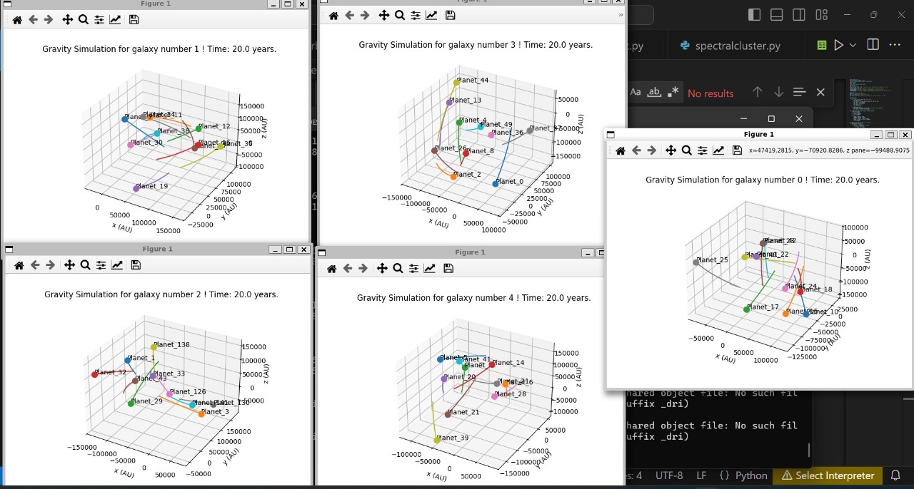

1. **CONCLUSION**

The Astronomical Event Simulator successfully achieved its objective of simulating galaxy formation while adhering to the fundamental laws of physics. By transitioning from Machine Learning regression models to physics-based mathematical models, the simulation demonstrated significant improvements in both accuracy and physical realism. The Explosion Model provided realistic initial conditions for planetary bodies, which were then grouped into galaxies using Gravitational Clustering. This method, grounded in gravitational principles, ensured the correct formation of galaxy structures. The final refinement through the N-Body Simulation further enhanced the accuracy, allowing for the dynamic simulation of planetary interactions that adhered to the laws of motion and gravity.

The results indicate that the simulator not only predicted galaxy formation but did so with a high degree of accuracy, validating both the simulation's output and its adherence to key physical principles such as conservation of energy and momentum. These findings confirm the effectiveness of combining computational techniques with astrophysical models to simulate large-scale cosmic phenomena.

Moving forward, there is potential to enhance the model by incorporating additional factors such as dark matter, which could provide a more comprehensive understanding of galaxy formation. Additionally, advanced techniques like reinforcement learning could be explored to model dynamic, evolving galaxies more accurately. Overall, the Astronomical Event Simulator provides a valuable framework for simulating the complex processes of galaxy formation and offers significant potential for further research and development in astrophysical simulations.

1. **FUTURE WORK**

While the Astronomical Event Simulator has successfully demonstrated the potential of combining gravitational clustering and N-Body simulations to model galaxy formation, there are several avenues for future improvement and exploration that could further enhance the accuracy and realism of the simulations.

Incorporating Dark Matter

One of the key factors that influence galaxy formation and dynamics is dark matter, which has a significant impact on the gravitational structure of galaxies. Future work could focus on incorporating dark matter into the simulation, allowing for a more comprehensive representation of the forces that shape galaxies. This would require modifications to the Gravitational Clustering and N-Body Simulation models to account for the effects of dark matter on gravitational interactions and galaxy dynamics.

Advanced Models of Galactic Evolution

Currently, the simulation primarily focuses on galaxy formation based on initial conditions and gravitational interactions. To better simulate the long-term evolution of galaxies, additional factors such as stellar evolution, supernovae explosions, and black hole dynamics could be integrated. This would allow for the modeling of how galaxies evolve over billions of years, including star formation, the development of galactic cores, and the potential merging of galaxies.

Integration with High-Performance Computing (HPC)

To handle increasingly complex simulations and larger datasets, integrating the simulator with High-Performance Computing (HPC) infrastructure could significantly improve computational efficiency. By parallelizing the N-Body simulations and clustering algorithms, the model could simulate larger regions of the universe, allowing for more detailed studies of galaxy formation on cosmic scales.

By addressing these areas of future work, the Astronomical Event Simulator has the potential to become a more comprehensive tool for simulating galaxy formation and evolution, offering deeper insights into the complexities of the universe.

1. **REFERENCES**

[1] <http://faculty.uml.edu/cbyrne/cbyrne.html> , <https://www.jstor.org/stable/4025081>

[2] Orbital Mechanics for Engineering Students, Second Edition, Howard D. Curtis <https://data.nasa.gov/>

[3] Longair Galaxy Formation, Malcolm S. <http://www.scholarpedia.org/article/N-body_simulations_(gravitational)>

**Ppt link:** [**https://www.canva.com/design/DAGXv-0oGkI/LLVv1jQCr-Aw9J_zRCmoyA/edit?utm_content=DAGXv-0oGkI&utm_campaign=designshare&utm_medium=link2&utm_source=sharebutton**](https://www.canva.com/design/DAGXv-0oGkI/LLVv1jQCr-Aw9J_zRCmoyA/edit?utm_content=DAGXv-0oGkI&utm_campaign=designshare&utm_medium=link2&utm_source=sharebutton)